

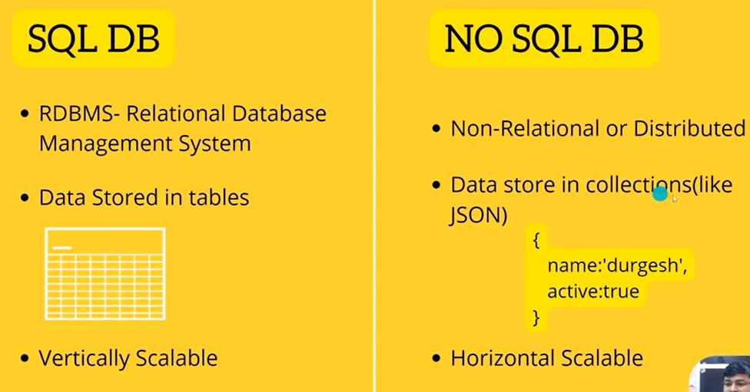

In c folder create data and inside db folder

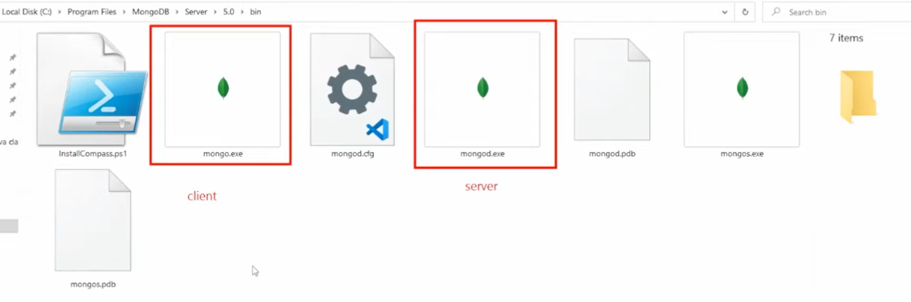

Open two CMD in that bin folder and write

1 CMD = mongo = client

2 CMD = mongod = server = 27017

If you want that you want run server and client from any folder then set path

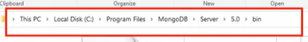

Open edit system env

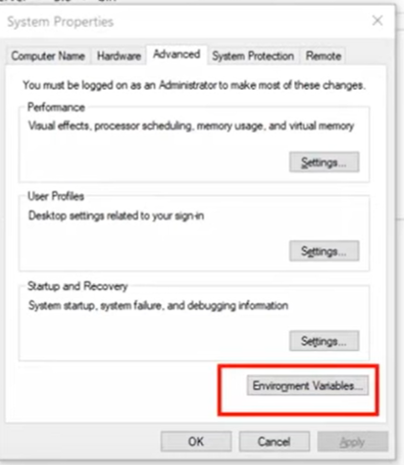

In path click on edit then paste your path - C:\Program Files\MongoDB\Server\5.0\bin

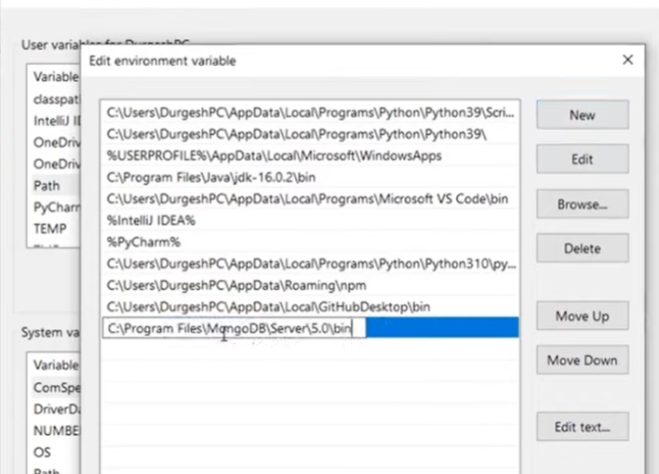

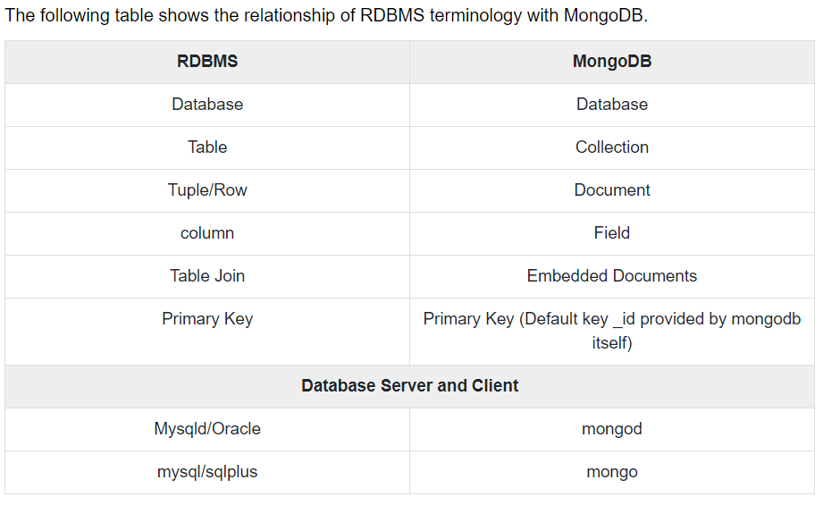

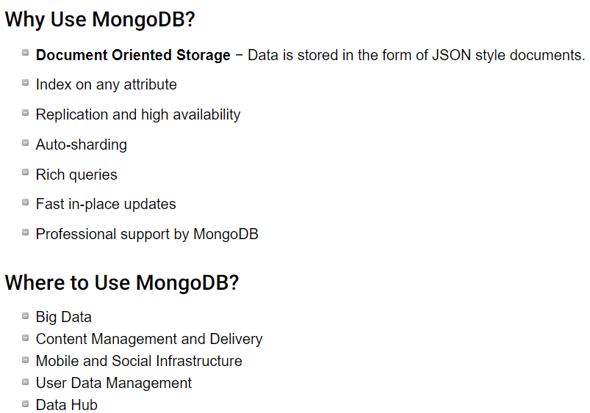

Command :

https://geekflare.com/mongodb-queries-examples/

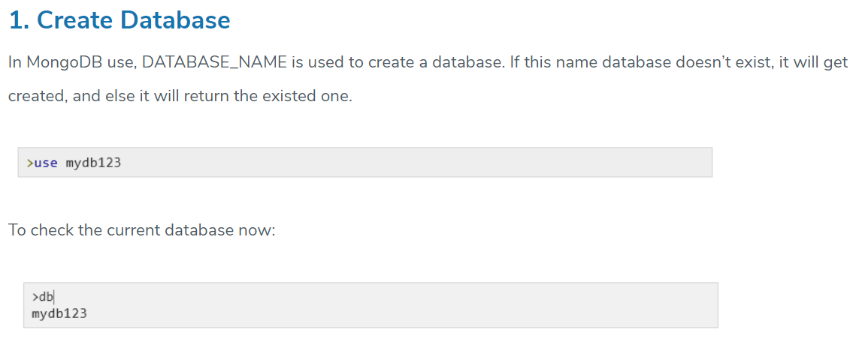

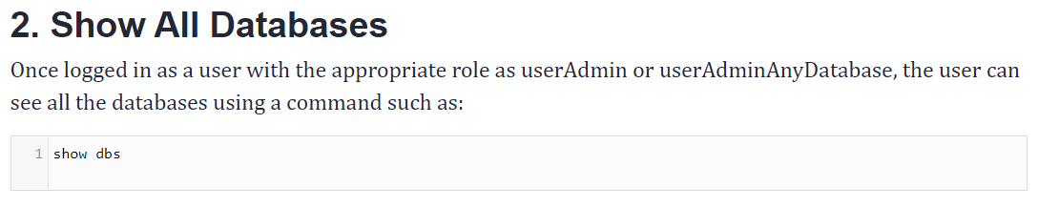

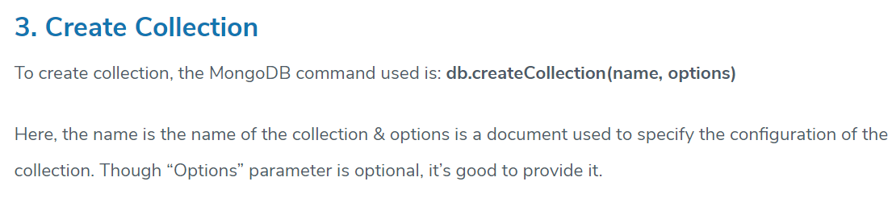

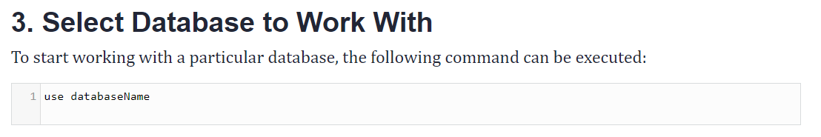

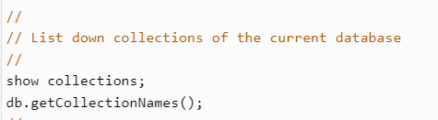

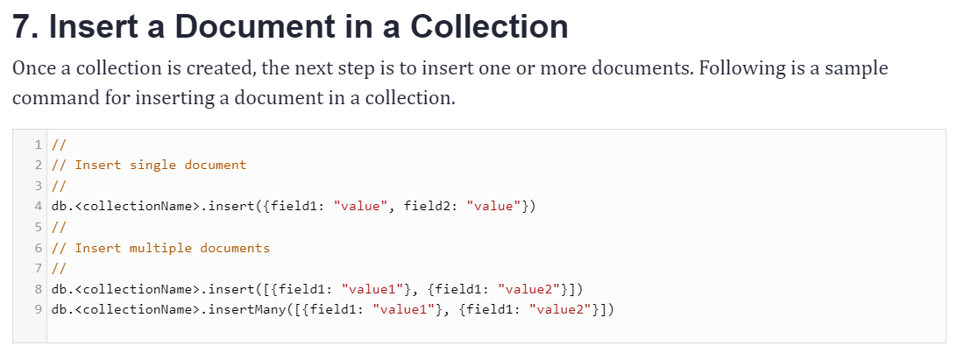

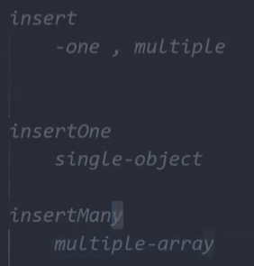

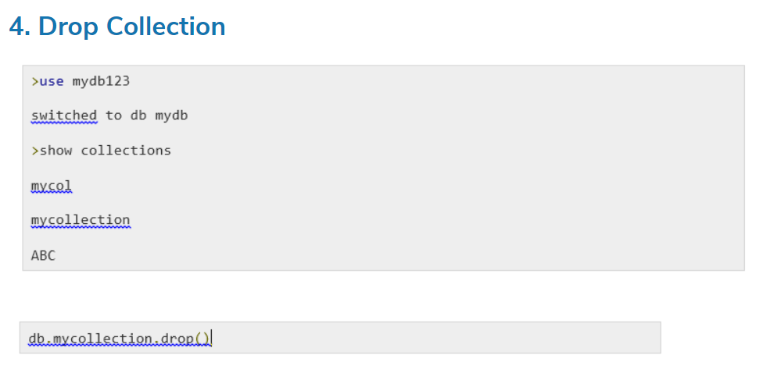

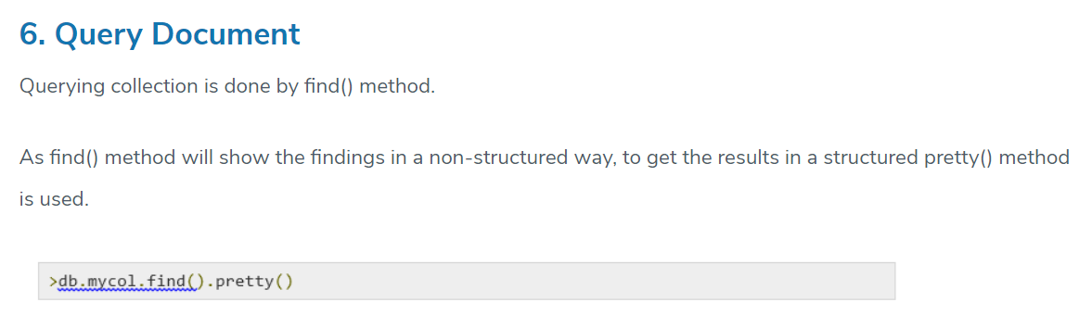



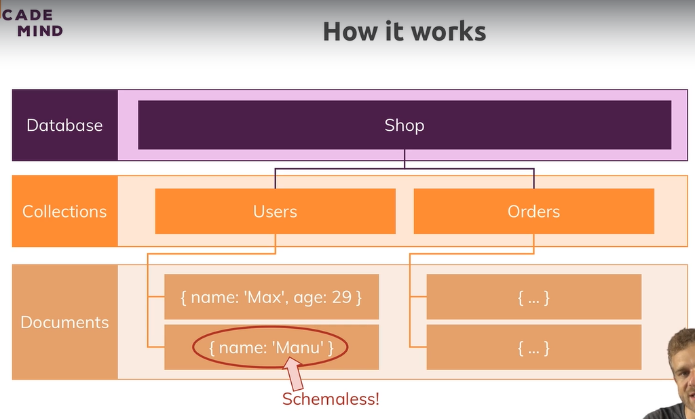

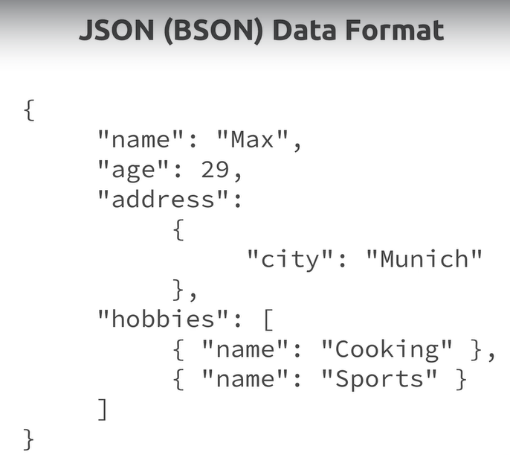

**Binary Javascript Object Notation**.

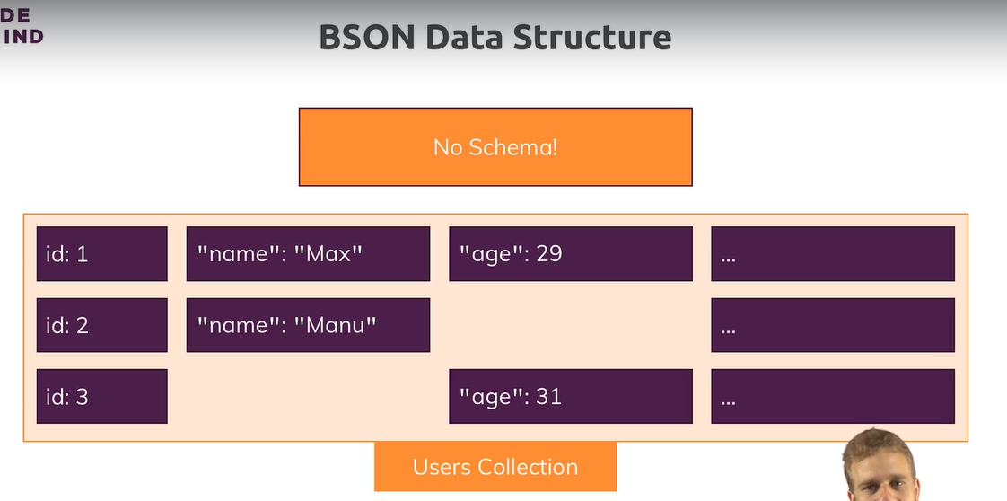

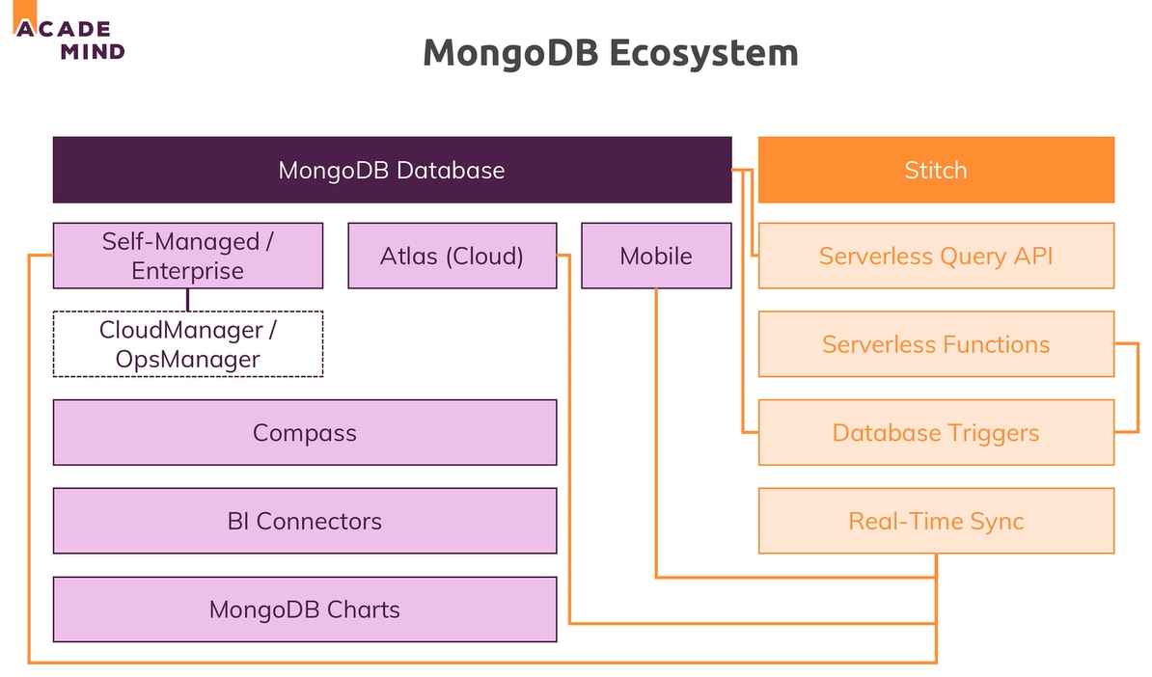

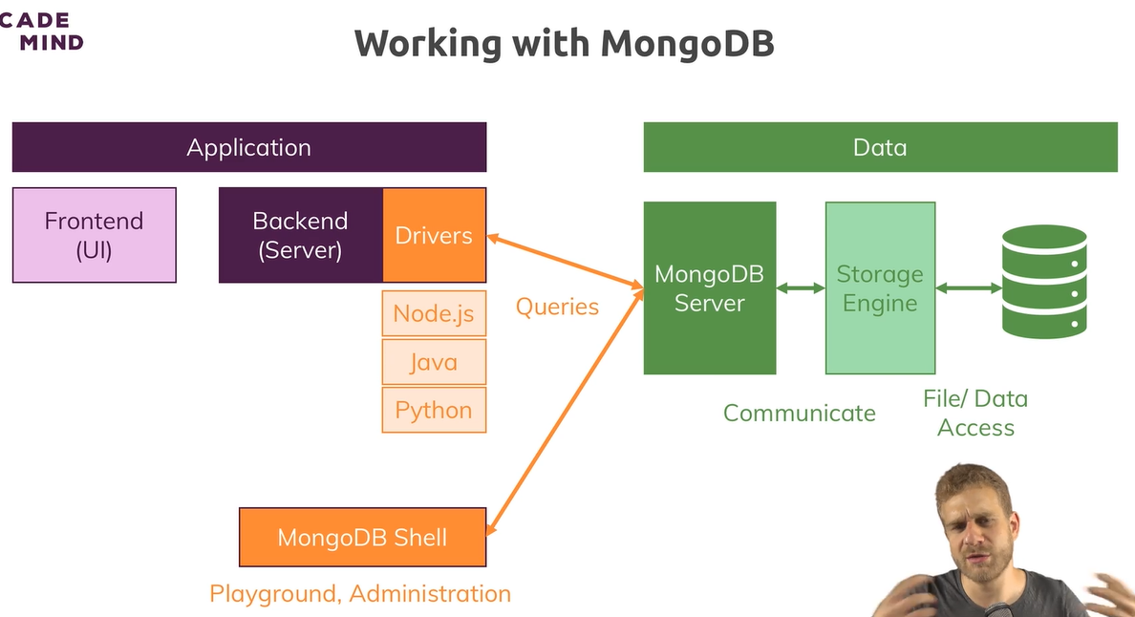

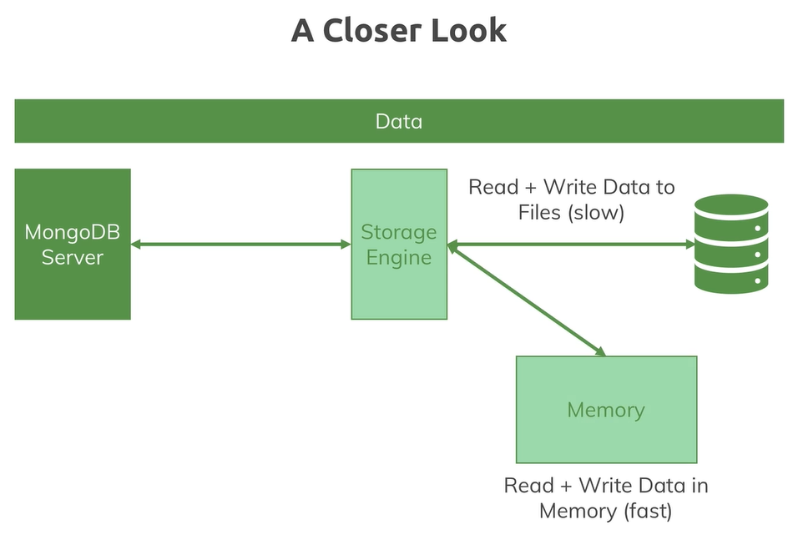

Change port of mongod server :

* mongod –port port_no

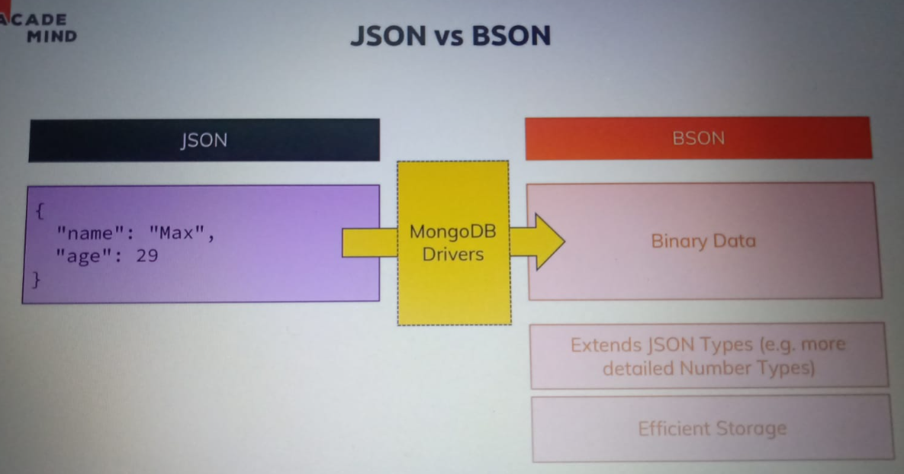

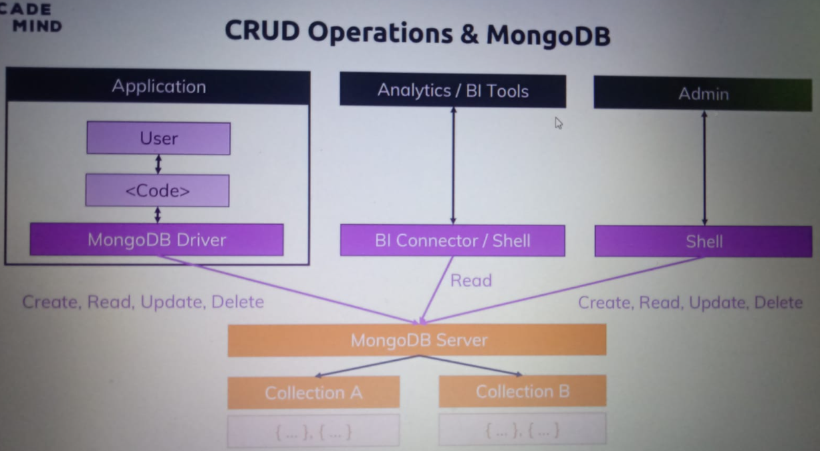

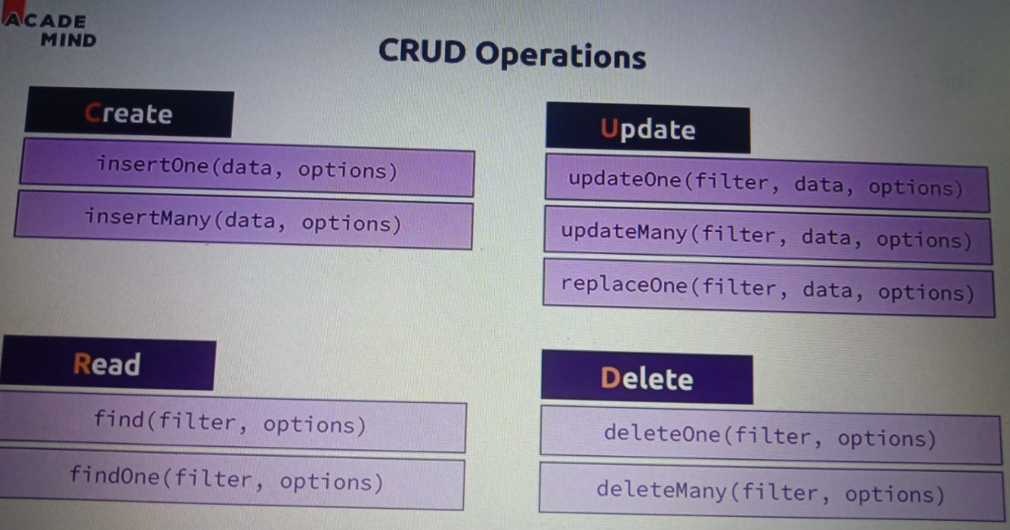

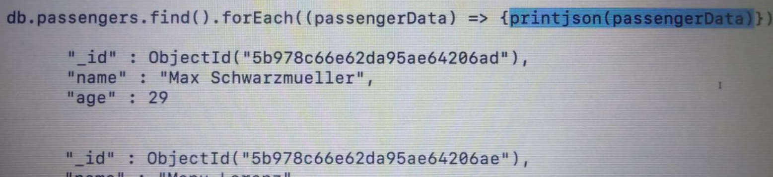

On findOne u can’t apply pretty() method

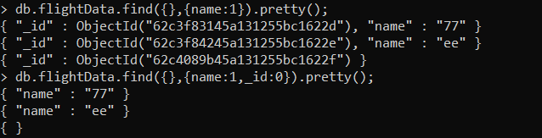

First one- Here you can find or project document on the basis of keys

Second one – if you want to exclude other and only want name

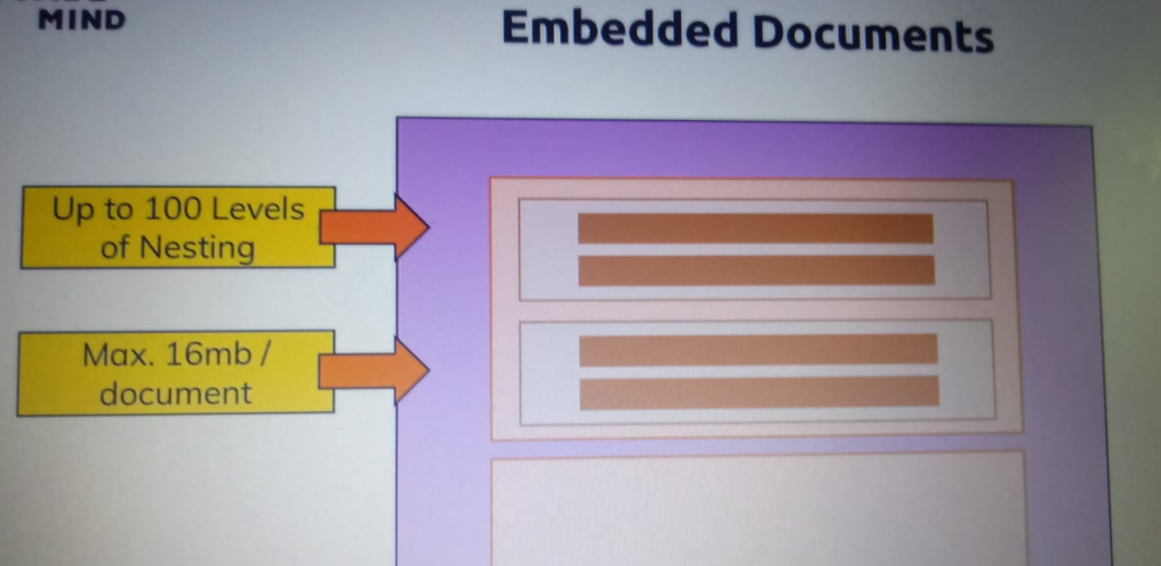

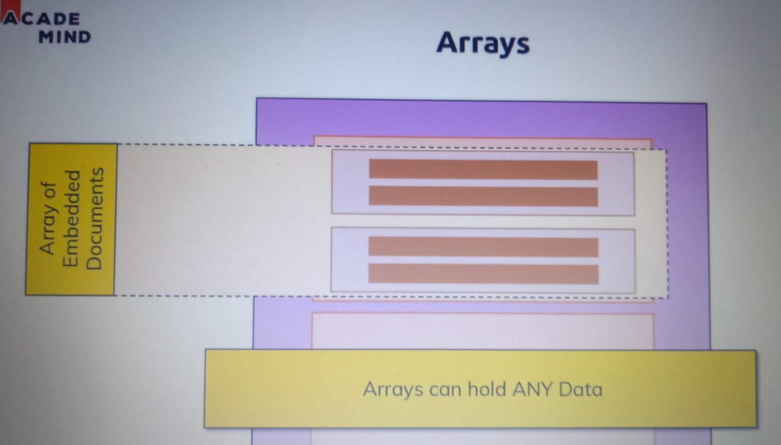

Nested array :

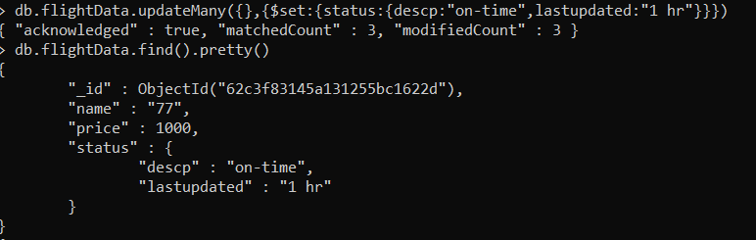

Array :

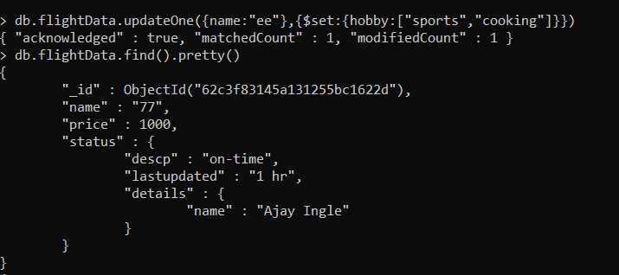

Find array value

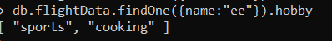

Search nested array;

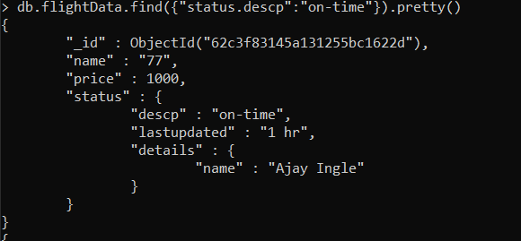

Delete array of data

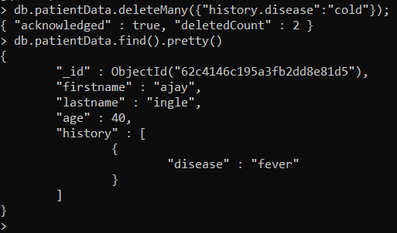

Use opetaor



Update use $set



Delete all = deleteMany({})

**Structure of document Is schema**

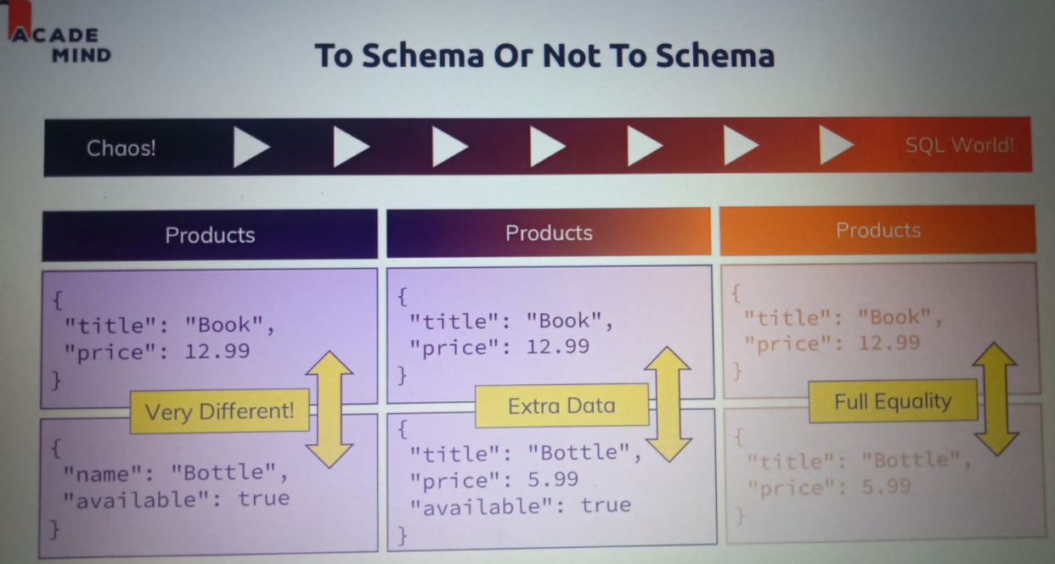

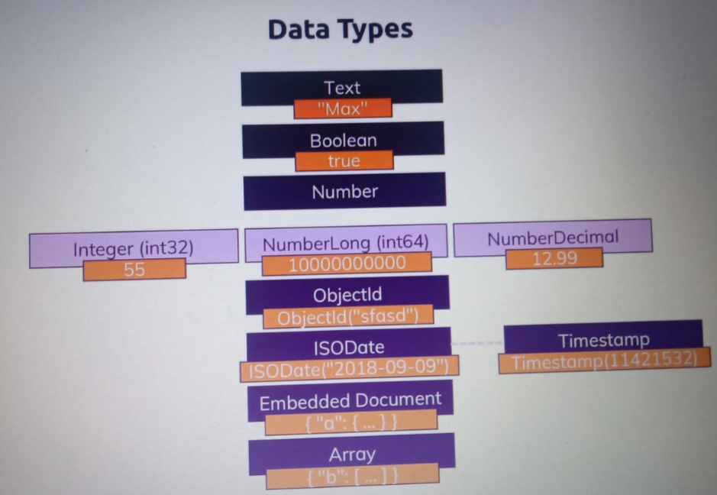

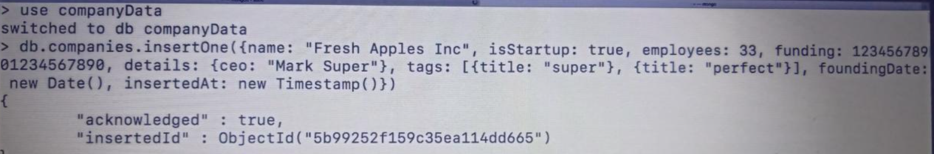

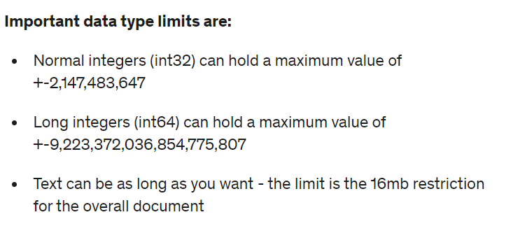

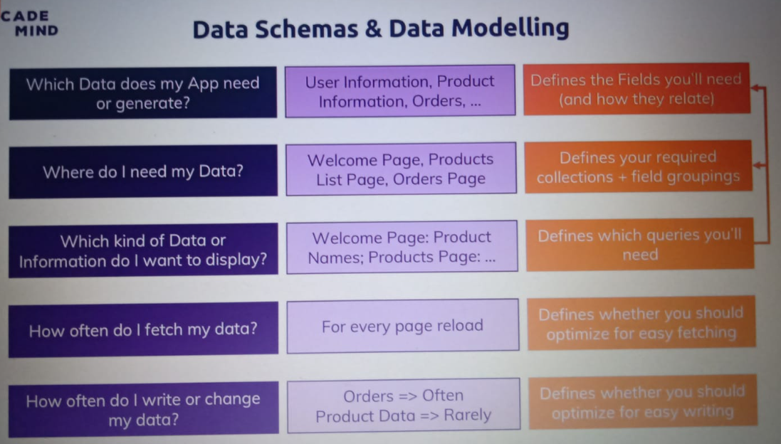

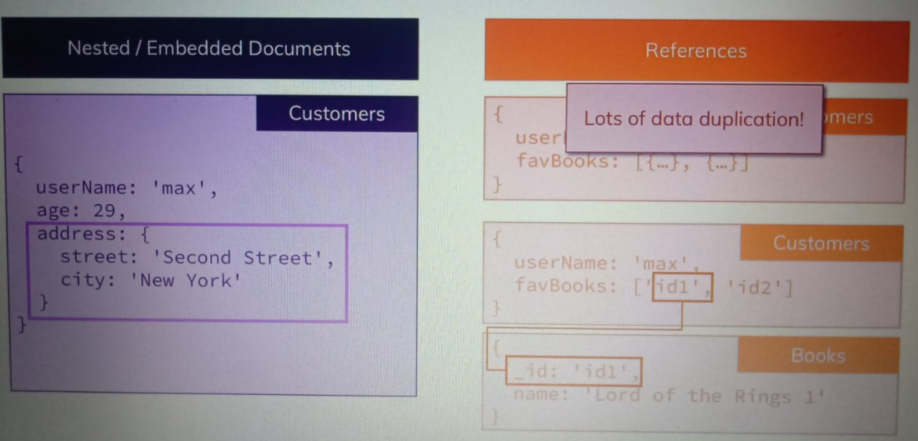

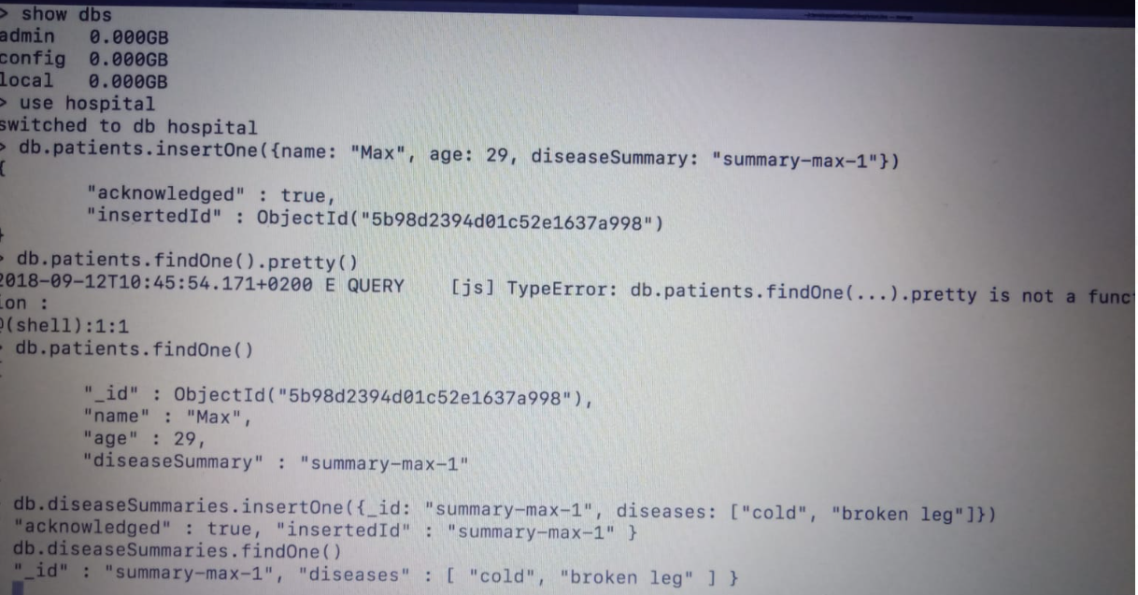

**Want summary of each patient : One-to-One**

**Every patient has only one summary histroy..**

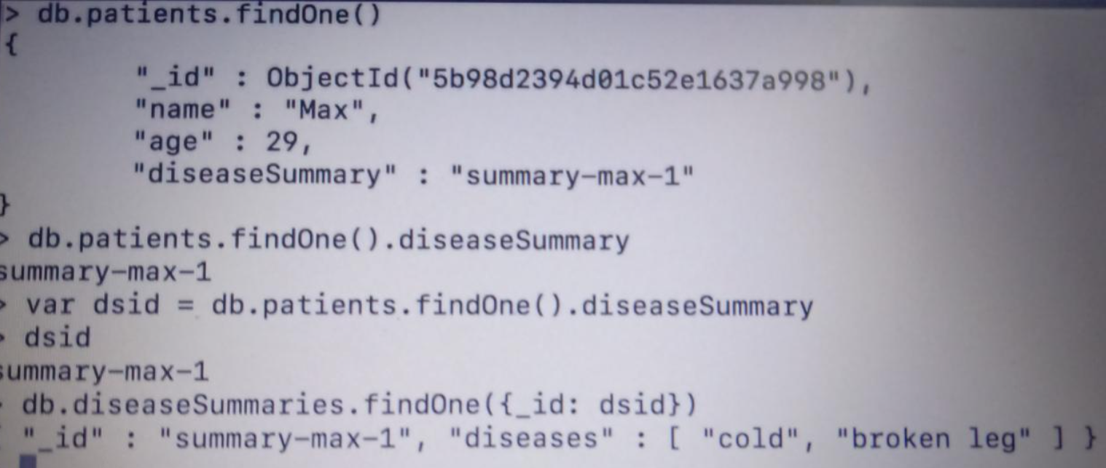

**This is approach 1 – use for small data - embedded**

**But for large data we have to do other approach: - refrences**

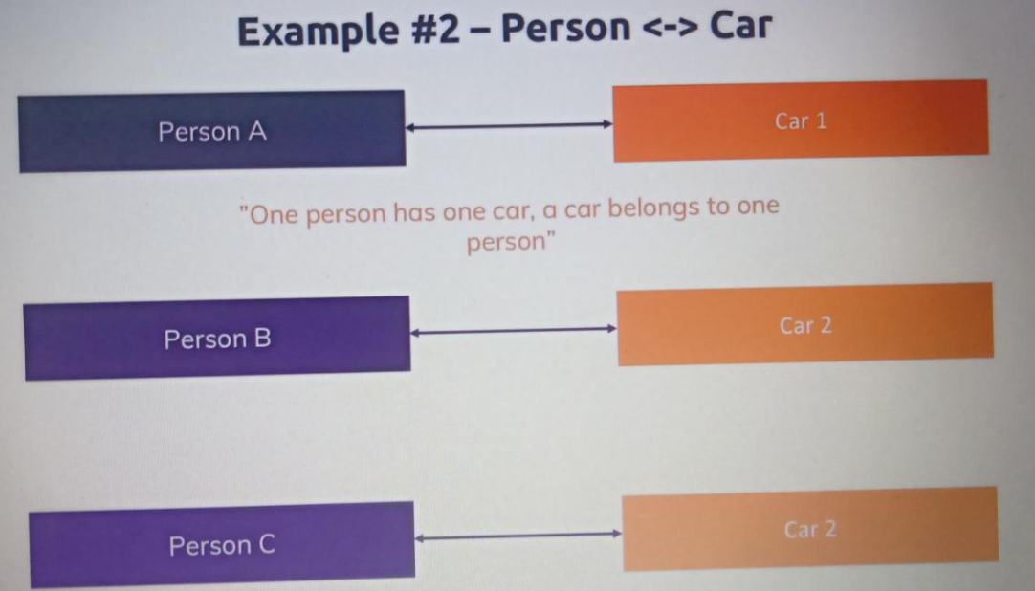

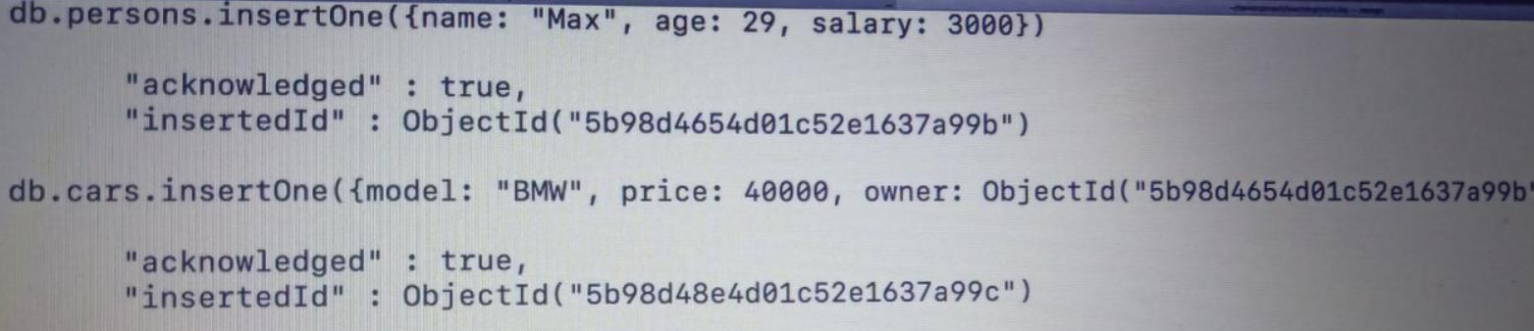

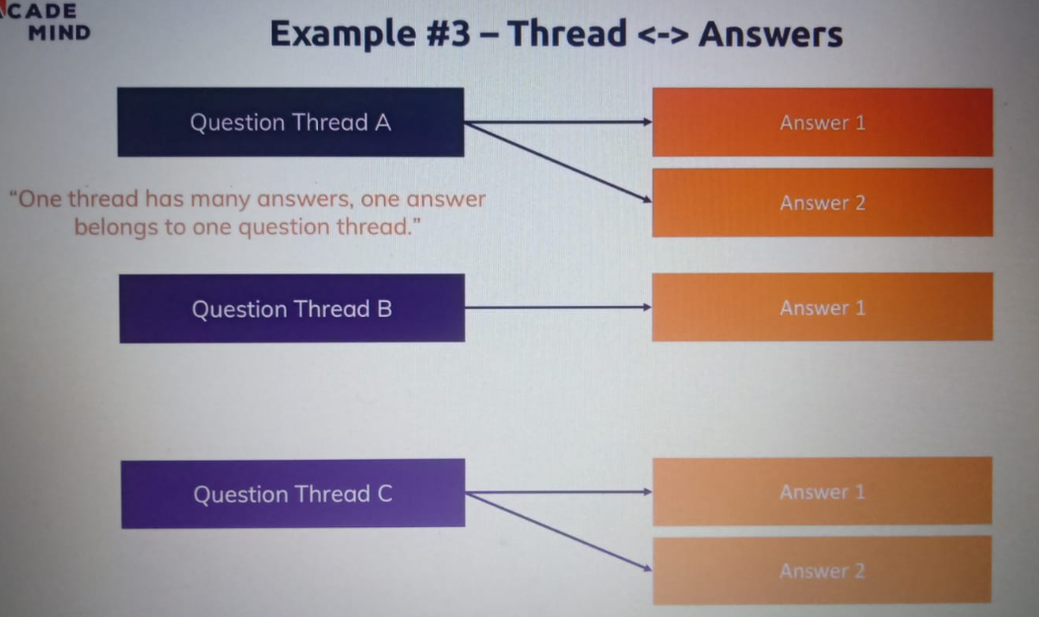

**One to Many : one que can have multiple answers…**

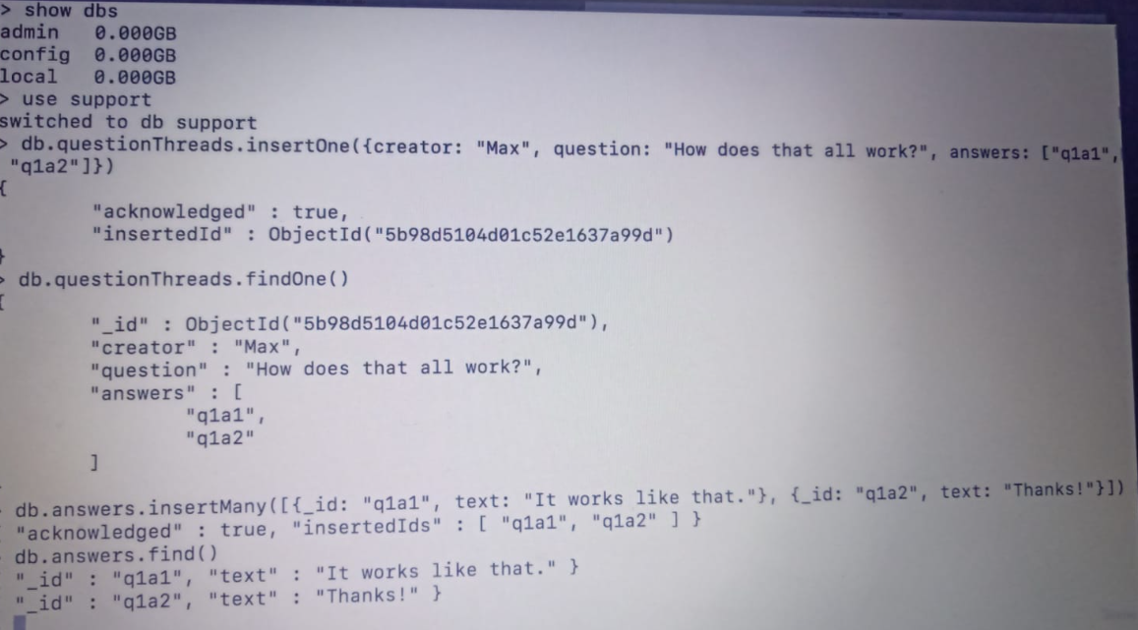

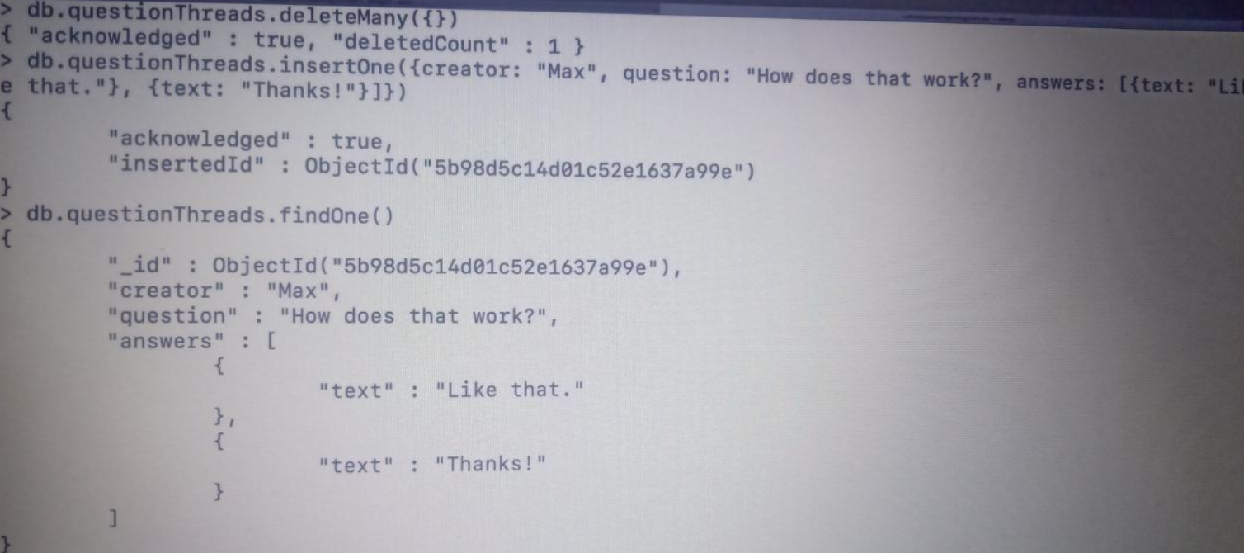

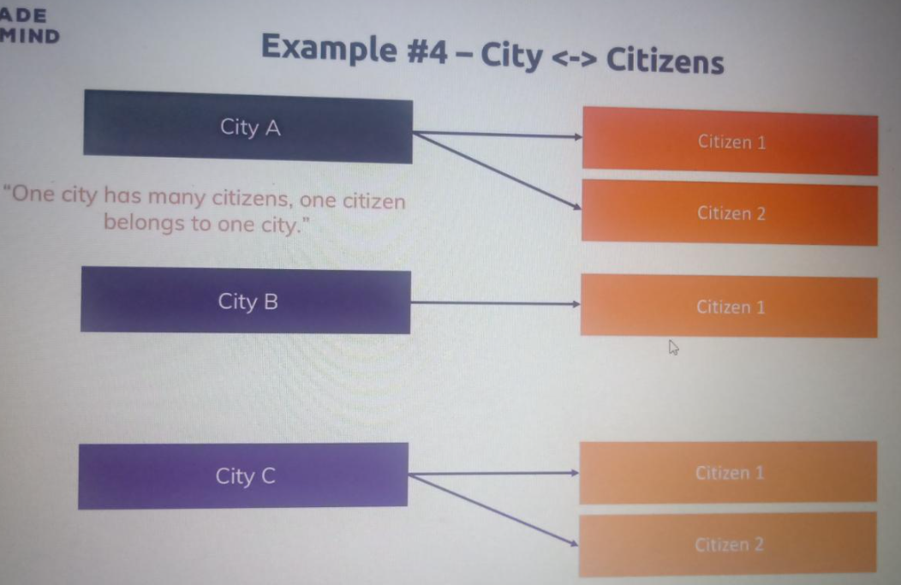

References:

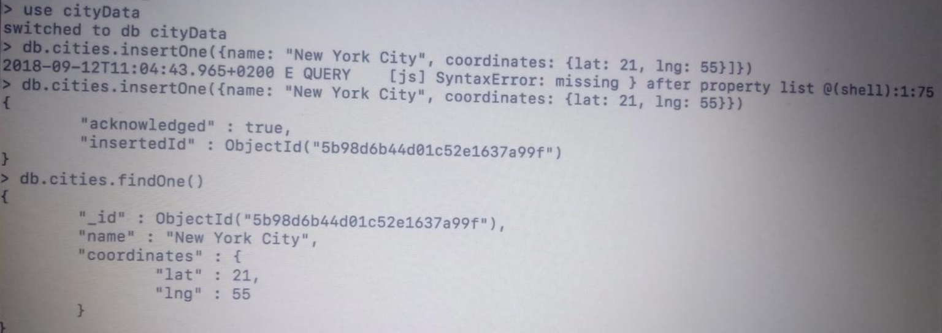

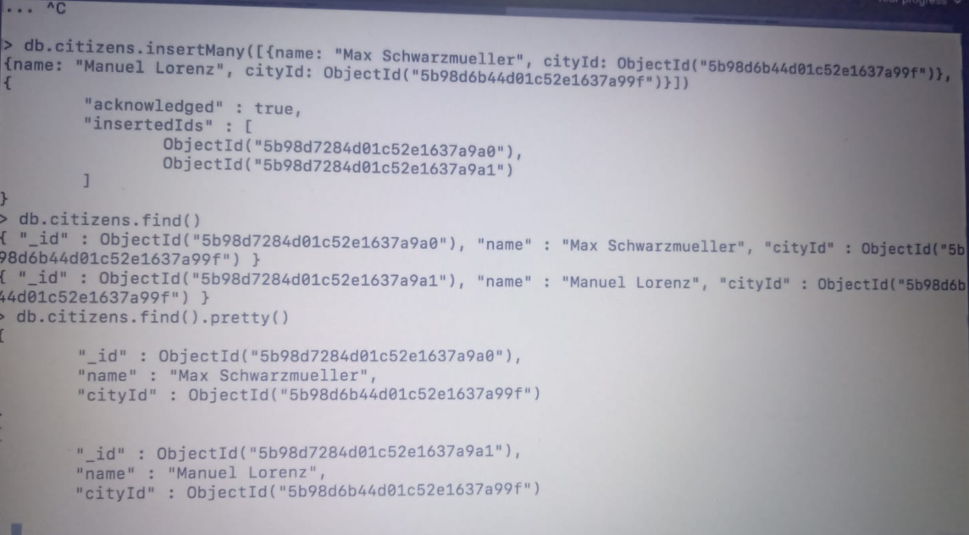

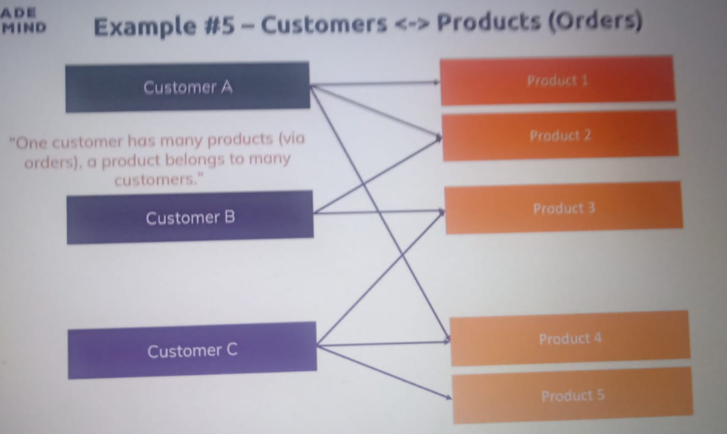

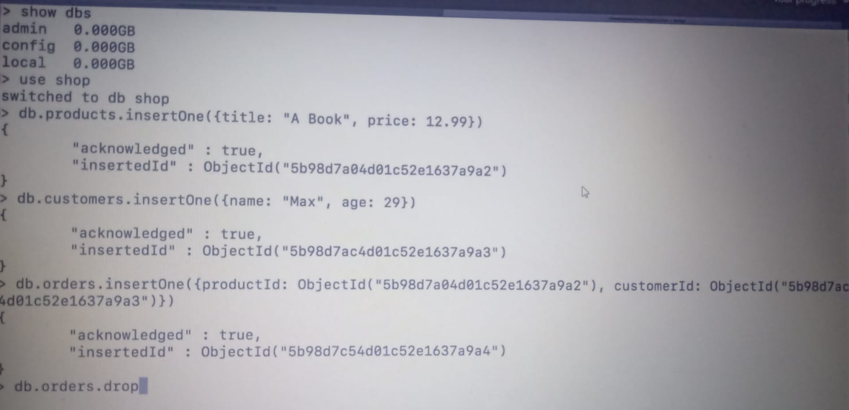

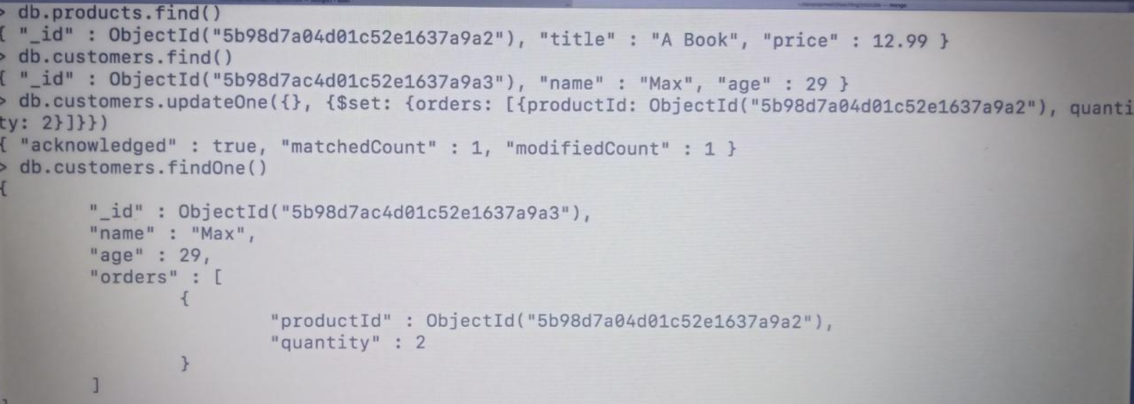

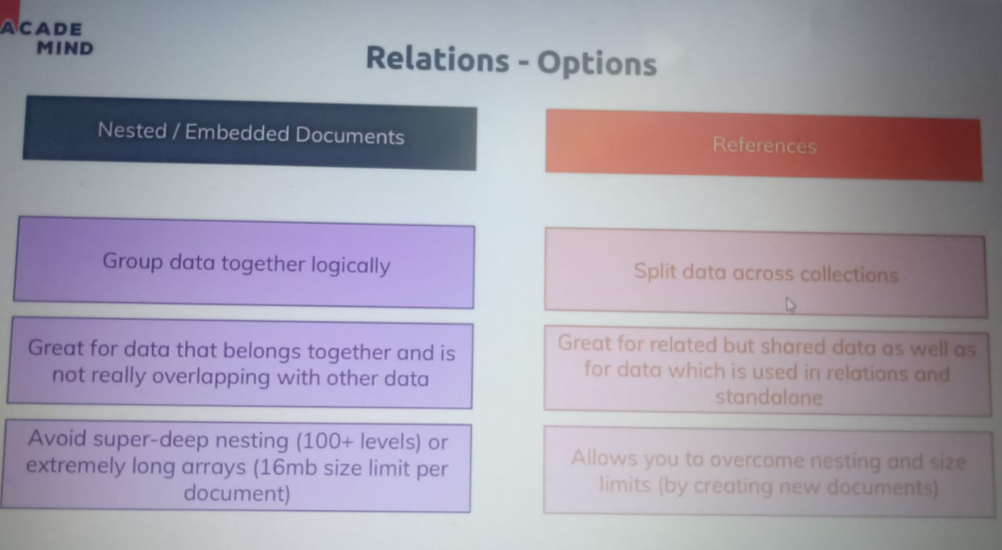

Lookup is important for add objects in one another or merge like ref

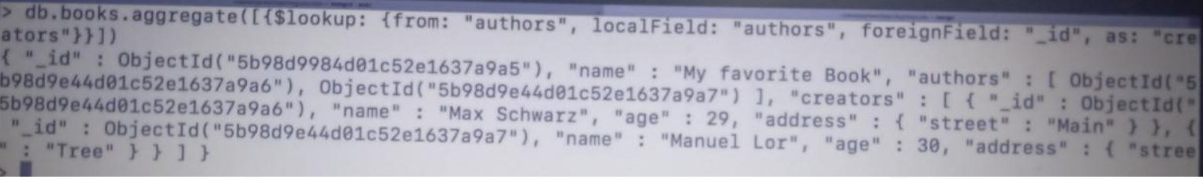

Schema validation :

Check your data type of data correct or not.

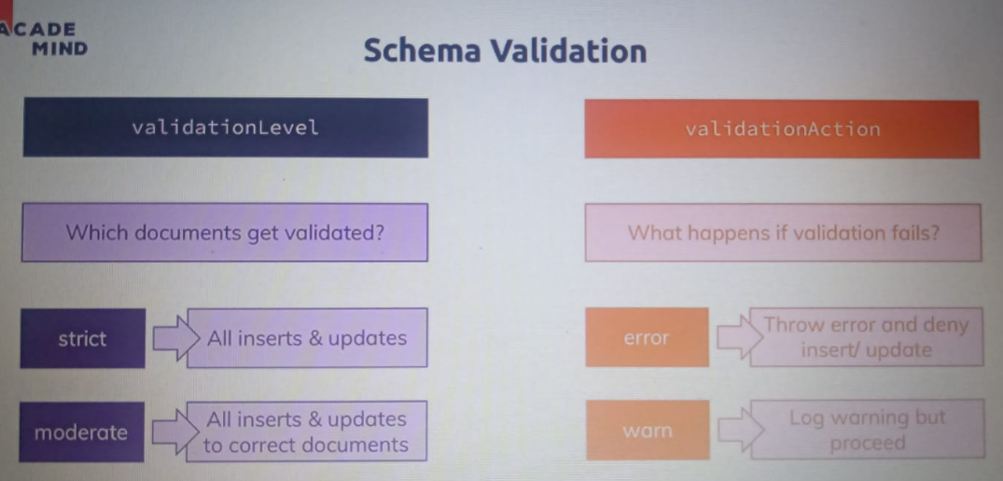

db.createCollection('posts', {

validator: {

$jsonSchema: {

bsonType: 'object',

required: ['title', 'text', 'creator', 'comments'],

properties: {

title: {

bsonType: 'string',

description: 'must be a string and is required'

},

text: {

bsonType: 'string',

description: 'must be a string and is required'

},

creator: {

bsonType: 'objectId',

description: 'must be an objectid and is required'

},

comments: {

bsonType: 'array',

description: 'must be an array and is required',

items: {

bsonType: 'object',

required: ['text', 'author'],

properties: {

text: {

bsonType: 'string',

description: 'must be a string and is required'

},

author: {

bsonType: 'objectId',

description: 'must be an objectid and is required'

}

}

}

}

}

}

}

});

Approach 2 :

db.runCommand({

// collection modifier..

collMod: 'posts',

validator: {

$jsonSchema: {

bsonType: 'object',

required: ['title', 'text', 'creator', 'comments'],

properties: {

title: {

bsonType: 'string',

description: 'must be a string and is required'

},

text: {

bsonType: 'string',

description: 'must be a string and is required'

},

creator: {

bsonType: 'objectId',

description: 'must be an objectid and is required'

},

comments: {

bsonType: 'array',

description: 'must be an array and is required',

items: {

bsonType: 'object',

required: ['text', 'author'],

properties: {

text: {

bsonType: 'string',

description: 'must be a string and is required'

},

author: {

bsonType: 'objectId',

description: 'must be an objectid and is required'

}

}

}

}

}

}

},

validationAction: 'warn'

});